Author: DavidMDavis.com

# Cloud Computing

* It’s Everywhere [Used around the world in many forms by people and companies]
* It’s Powerful [Can run any application, anywhere, anytime, ay any scale]
* It Makes your life easier [Allow to do more with less, more efficient, save time and money]

Cloud computing is on demanding resources, delivered to you over the internet.

OR

Cloud computing is a computing services which you traditionally did local, now performed remotely, across the internet.

**Traits of Cloud**

Elastic: Scales up or down quickly

Metered: Pay only for what you use

Self-Service: No need for IT Experts

Where are my applications running?

Where is my data stored?

* Answer to the above questions, until you pay amount to the cloud provider till that no need to think for software installation, security of data, upgrade of the system, Scale up/down. Depends on the uses pay to the provider.

**Benefits of Cloud Computing**

* Faster access to resources or applications you or your company (Getting mail server for company)
* Only pay for what you use (Pay for per month/per user instead of getting physical server with fixed capacity)
* No capital expenditure to get started (No need to get physical server or license or Microsoft license)
* Potential to eliminate the need for local IT staff to maintain infrastructure and applications.
* Potential to lower costs.
* Deploy what you need, yourself, with self-service. (Setting-up mail server for small company)
* Allow IT staff to focus on the business. (Will provide more business value)

**Risk of Cloud Computing**

* Placing your trust in the cloud provider. (If service go down then complete loss. Sometimes provider has downtime or performance slowdown by the time no access to data.)
* Potential for data loss. (Should take back-up from one cloud provider to another cloud provider)
* Potential for slow access to your data.
* Potential questions related to legal/regulatory (Email will be fine but health data, employee data or financial data of government should not be stored outside of the country)
* Potential for loss of customization.
* Potential for unknown costs.

**SaaS (Software as a Service):** Accessing application which is already running in cloud. Just make use of them. Ex: Gmail, Office 365, SalesForce.com, Dropbox

**IaaS (Infrastructure as a Service):** Accessing virtual machine. Instance of a physical computer virtualized and running in the cloud which has virtual hard disk, CPU, memory, networking. Her you can install web server, database server)

**PaaS (Platform as a Service):** Developer who need access to development platform could be SQL server to deploy server. Or Web server which is running and they need to put code on that web server and deploy a new web application. Pay per transaction, utility based consumption model)

**IaaS (Infrastructure as a Service)**

**Virtualization**: It is the logical division of physical computing resources.

Convert physical server as virtual host and virtual host can run virtual machine.

**Virtual Machine**

* Hypervisor is core piece of Virtualization solution.
* A Virtual Machine is software-based instance of physical server where a guest operating system has access to matched/emulated virtual hardware.
* Virtual machine runs on hypervisor.
* Virtual guest run on virtual host, which provides the physical resources.
* User feels as they can access physical hardware or to the physical server.

**Container**

Container is operating-system level virtualization where the OS kernel provides isolated user spaces to run specific applications.

* Could run inside a virtual machine.
* Have less overhead and faster startup time than virtual machines.
* Become popular because of Docker containers.

Private Cloud

* Run for own building, own datacenter for company to leverage. You’re are not paying to someone else and not access data across internet.

Public Cloud

* **IaaS comes under public cloud**. As AWS EC2 and Azure Virtual Machine.

Hybrid Cloud (Known as Enterprise Cloud too)

* Looks like cloud and application running there. Actually, there is not real hybrid cloud.
* There is no real place in hybrid cloud as your application would be running.
* Here you would be connecting private cloud to public cloud to create this hybrid cloud.

Ex: Database in private cloud and web server in public cloud to scale-up easily.

|  |  |
| --- | --- |
| **Virtualization** | **Private Cloud** |
| * Require for cloud computing. * Virtualization provides Scalability and Elastic computing. * Resource sharing and Pooling. * Load balancing * High Availability * Portability (Private Infra to Public) * Cloning (Existing Application and do duplicate entire virtual guest application) | * Work on top of virtualization * Secure multi-tenancy (For more than one company) * Self-Service portal (Easy to deploy new, just few clicks) * Catalog of application (Running application list) * Chargeback/showback (Report on usages and used for billing) * Potential to burst to a hybrid cloud (Connect with public cloud) |

**IaaS (Infrastructure as a Service)**

Pricing is ideally, utility/ consumption/ subscription-based where you pay for what you use.

**IaaS (Infrastructure as a Service) Networking**

How servers will get connect to laaS? Below are the options:

Public Networking: Use public IP addresses via browser.

Private Networking: Use VPN (Virtual Private Network) or dedicated connections.

**Storage in Cloud**

Major two options for data storage for laaS:

1. Inside the Virtual Machine *(Each VM has own storage)*
2. Outside the Virtual Machine *(Each VM can access external storage like block or object storage. Ex: Amazon has Elastic Block Storage(EBS) shard storage system for all virtual machine in the cloud.*

*Ex: Object storage would be used for unstructured data)*

**Cloud File Storage**

* Dropbox
* Microsoft Onedrive
* Google Drive

**Object Storage**

Used to used unstructured data like pictures, videos and archival data. (Pay for how much volume you consume/Store in cloud)

* Amazon web services S3 (Simple Storage Service)
* Microsoft Azure Blob Storage

**Data Protection in Cloud**

Below are the few plan to protect your data: (Disaster recovery can be done)

* Crash Plan – Automatic Online Backup
* AWS Storage Gateway
* Microsoft Azure Backup

**IaaS Security**

Common concerns:

* Is my data safe?
* Who can see my data?
* Can my data be modified?
* Who is responsible for securing my data?

Cloud provider used to give option to encrypt your data in VM or object storages. Data would be safe unless you know the software key to decrypt it.

**PaaS (Platform as a Service)**

* A cloud service for developers who wants to develop, run and manage applications.
* No server, storage, network, OS, middleware or database needed. (Nothing to be install or configure)

Example for PaaS:

* AWS Elastic Beanstalk
* Microsoft Azure App Service
* Google App Engine
* Cloud Foundry
* Heroku

|  |  |
| --- | --- |
| **IaaS** | **PaaS** |
| * All servers, storage and networking are provided. * Developers must install their own software such as web servers, database servers etc. | * PaaS runs on top of infrastructure as a service. * Developers have access to already installed web servers, database servers and development libraries. |

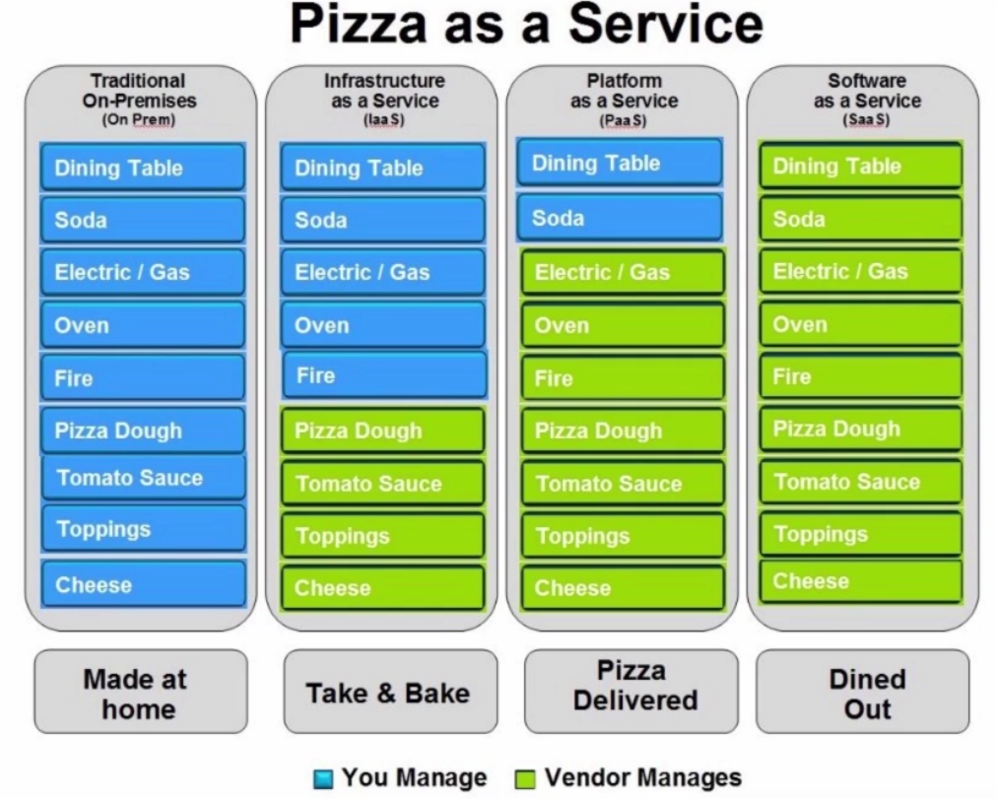

**Benefits for SaaS (Software as a Service)**

* No Hardware to buy or install
* No software to buy or install
* No software to maintain or upgrade
* You only pay for what you use
* New features are included
* Most everyone can afford and use applications that used to be only for large corporations.

SaaS Example: Office 365 (Microsoft), Google G Suite, Salesforec.com (CRM Tool – Customer relationship management)